|  |  |  |  |  |  |  |  |  |  |  |
| --- | --- | --- | --- | --- | --- | --- | --- | --- | --- | --- |
| Lal ghai & Associates | | | | | | | | | | |
| **Company Secretaries** | | | | | | | | | | |
| **NCR**: GF-390, Sector-31, Gurgaon-122001 (Haryana)  **LDH**: 4th Floor, Noble Enclave, Opp. Hotel Park Plaza, Bhai Wala Chowk,  Ludhiana (Punjab) – 141001, Tele: 0161-4610886 | | | | | | | | | | |
|  |  |  |  |  |  |  |  |  |  |  |
| CS. Rattan Lal Chanjotra, ACS | | |  |  |  |  |  |  | CS. Sumit Ghai, B Com, ACS, LLB | |
| 8284000886, 9876757396 | | |  |  |  |  |  |  | 9463640466 | |
| [rattanchanjotra@gmail.com](mailto:rattanchanjotra@gmail.com) | | |  |  |  |  |  |  | [cssumitghai@gmail.com](mailto:cssumitghai@gmail.com) | |
|  |  |  |  |  |  |  |  |  |  |  |

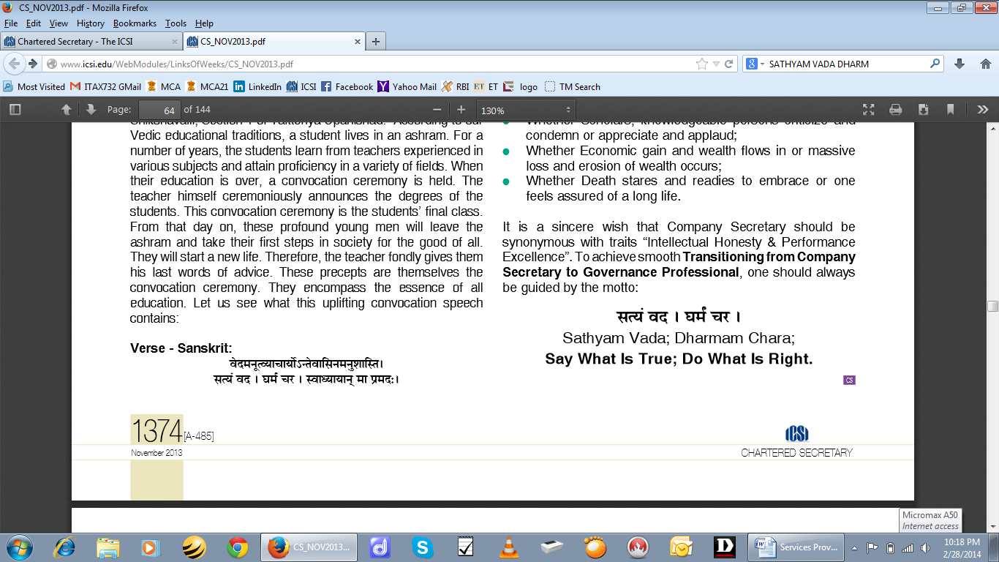

**FIRM’S PROFILE**

Asthe above motto of our firm denotes, we believe “Strong and healthy tree bears fruit.” This law of nature applies to all, even corporate. So, we promote compliance of statutes, forming a code of conduct, healthy practices and regular check-ups in our associate firms, thus laying a strong foundation for a healthy growth.

We shall continually add value to the clients business through a visionary, efficient and optimal blend of services through human resources, values and technology. The client driven approach and value added services & solutions are our key strengths.

Lal Ghai & Associates established in 2013. It is a team of client committed, self-motivated, young and dynamic Company Secretaries specializing in their respective practices, holding multiple academic qualifications and experiences. We endeavor to widen and maintain our client base by continuously adhering to the highest professional standards. We always strive to cross new horizons by exploiting new avenues of services through learning & new ideas. In line to achieve our goal, we keep ourselves abreast with the frequent changes to the laws by participating in seminars, workshops arranged by the ICSI or other agencies.

The team of Lal Ghai & Associates:

**CS. Rattan Lal Chanjotra, ACS**

He is an Associate member of the Institute of Company Secretaries of India (ICSI). Before coming up as founder Partner of Lal Ghai & Associates, he earned rich experience of over 18 years by rendering services in different capacities in Government as well as private sector with various reputed organizations from 1995 to 2013. During his employment tenure in renowned Steel Company, he effectively handled and executed various projects under Theory of Constraints (TOC) in consultation with GOLDRATT (INDIA), a leading management consultancy firm.

He enjoys varied experience in management of various corporate affairs, strategic issues, corporate communication, legal compliances, FEMA, FCRA etc. He also appeared before the Statutory Tribunals like Regional Director (Northern Region), Ministry of Corporate Affairs on behalf of clients. He is also involved in various assignments related to Foreign Direct Investment (FDI) and Overseas Direct Investment (ODI). He effectively ensures compliances of SEBI related laws & regulations applicable to listed companies. He also takes care of compliance and procedure related to incorporation and management of LLP.

He is providing professional services to leading listed companies as Independent Director. He is also a member of Management Committee of Ludhiana Chapter of ICSI.

He is also a partner in DR Associates a leading firm of Company Secretaries operating in NCR region.

**CS. Sumit Ghai, B Com, ACS, LLB**

He is a Law Graduate and an Associate member of Institute of Company Secretaries of India. Before taking-up as founder partner in Lal Ghai & Associates, he has obtained a wide variety of Experience in Accounts, Finance, Secretarial related matters by working in renowned business organization in Ludhiana. During his job tenure as an Associate Secretary, he has acquired an intricate knowledge of the Secretarial Practices & Intellectual Property Rights (IPRs) matters including appearance before the Statutory Tribunals like Regional Director (Northern Region), Ministry of Corporate Affairs and Trade Mark Registry (North).

He handles matters of Company Law, Intellectual Property Rights and other Legal matters of the client Companies including Non-Banking Financial Companies (NBFC). He has expert knowledge of matters related to Secretarial Practices such as holding Shareholders’ Meeting, Board Meeting, Shifting of Registered Officer from One State to another State etc. He is involved in assignments related to due diligence under Companies Laws and formation of OPC, LLPs, registration of Society & Trust.

He is also a partner in DR Associates a leading firm of Company Secretaries operating in NCR region.

The Firm is providing a wide gamut of services in matters relating to the Company Law and other Corporate Laws:

**Company Laws**

1. Secretarial / Internal Audit and Compliance Management
2. Formation of Company / OPC / LLP / Section 8 Company
3. Corporate Restructuring (Mergers, De-merger, Amalgamation, Takeover, Buy Back etc.)
4. Charge Management – Registration, modification & Satisfaction
5. Organizing and Conducting General Meeting, Board Meeting & Class Meeting of company
6. Shares Transfer and Transmission
7. Alternation of Memorandum and Article of Association of Company
8. Liaison with ROC, RD, OL, CLB, NCLT and other Govt. authorities for approvals and other activities
9. Matters related to Oppression and Mismanagement
10. Annual Return and XBRL Filing under Companies Act
11. Maintenance of Secretarial records & statutory registers
12. Filing Forms, Returns & applications by and on behalf of the company
13. Legal opinion for matters under Company laws

**Legal Compliance Management Services**

1. Legal Audit
2. Due Diligence
3. Enterprise Risk Management
4. Contract Abstraction
5. Customized Software for Compliance Management

**SEBI Laws**

1. Listing of Securities (IPO / FPO / Right Issues)
2. Acquisition & Takeover under SEBI regulations
3. Corporate Governance and Compliances management under Listing Agreement & SEBI Laws
4. Procedural formalities for Preferential Issue/ Private Placement, ESOP, Bonus issue, Buy back
5. Internal Audit of Depository Participants / Portfolio Managers/ Stock Brokers
6. Concurrent Audit and Audit in relation to Reconciliation of Shares
7. Investor Protection Services
8. Compliances under Insider Trading
9. De-listing of securities from Stock Exchange
10. Management & Compliance of Postal Ballot

**Intellectual Property Rights**

1. Registration/Renewal of Trade Mark, Copy Right & Design
2. Advise / Online & manual Public Search for Trade Mark & Design
3. To file response of examination report & attend hearing
4. Opposing / Rectification of Trade Mark & Design
5. To advise and file reply to various notices related to Trade Mark, Copy Right & Design
6. To handle work related to Assignments, Licenses and User Agreements
7. IPR Protection & Investigation services for to prevent infringement

**Foreign Exchange Management**

1. Registration of Company as NBFC and setting up Liaison / Branch Office
2. Registration for Import Export Code (IEC) and membership of Export Promotion Councils
3. Foreign Collaborations and Joint Ventures Setting Joint Ventures/ Wholly owned subsidiaries abroad
4. Raising of funds from international markets ADR / GDR / FCCBs / FCEBs / ECB
5. Liaison with DGFT, FIPB & RBI for various approvals
6. Procedures and certification related to in-bound / out-bound transactions
7. Investment Advisory Services for NRIs
8. Representation before Adjudicating Authorities and Compounding of offences under FEMA

**Legal Services**

1. Drafting and vetting of various contracts and agreements

(a) Non-Disclosure Agreements

(b) Memorandum of Understanding

(c) Material Transfer Agreement

(d) e-Commerce Agreement

(e) Consultancy Agreement

(f) Sourcing Agreement

(g) Master Agreement

(h) Other Agreements

2. Drafting of legal pleadings and petitions

**Taxation Services**

1. Registration of Company / Firm under Excise, VAT, Service Tax
2. Preparing and filing of various returns and reports under tax laws and regulations
3. Representing Company/ Firm before the tax authorities

**Banking Services**

1. Diligence Report and Certification in respect of Consortium/multiple banking
2. Status and Search Report
3. Loan Syndication and Documentation
4. Project Reports and Feasibility Studies for Project Financing

**Registration Services**

1. Registration of Firm/ Society/ Trust / HUF
2. Registration of Society/ Trust to seek exemption in respect of donations under Income Tax (80G, 12A)
3. Registration of Trust / Society / Section 8 Company to receive Contribution / Donation from Foreign sources under Foreign Contribution (Regulations) Act 2010